**Water Wise Application: Design for Water Quality and Sustainability.**

Diksha Jain Vivekanand Kalaskar Sirivenni Pati

Pace University Pace University Pace University

Brooklyn, New York, USA Brooklyn, New York, USA Brooklyn, New York, USA

Dj06495n@pace.edu.in vk13755n.pace.edu Sp87215n@pace.edu

Vignesh Palla Tarun Ganta

Pace University Pace University

Brooklyn, New York, USA Brooklyn, New York, USA

VP74608P@pace.edu tg22281n@pace.edu

**ABSTRACT:**

The WaterWise app aims to empower users by providing easy access to vital information on water quality, consumption, and environmental impact. It combines real-time monitoring with educational resources to enhance water literacy and promote sustainable practices. Features includes customizable data displays, goal-setting tools, and social media integration to encourage user engagement. Through personalized notifications and suggestions, the app fosters ongoing dialogue and action towards water conservation, offering a comprehensive solution for sustainable water management.

**1 INTRODUCTION:**

The WaterWise app is a pioneering initiative aiming to empower individuals with extensive insights into water quality, consumption habits, and their environmental impacts. In a time where water safety is a paramount concern, many individuals remain unaware of their tap water's quality. This ignorance highlights the urgent necessity for innovative solutions not only to monitor water quality but also to educate and involve users in sustainable water management practices.

Our app leads this effort by providing users with seamless access to a plethora of information regarding their water supply. By integrating real-time monitoring capabilities with educational resources, WaterWise revolutionizes water literacy and conservation endeavors. Through customizable data displays, goal-setting tools, and social media integration, users are not just informed about water quality but also encouraged to actively contribute to preserving this invaluable resource.

WaterWise fundamentally acts as a catalyst for dialogue and action, promoting a community-driven approach to sustainable water management. Through personalized notifications and tailored recommendations, users are empowered to make informed decisions about their water usage, thereby contributing to a collective effort for conservation and environmental stewardship.

In the subsequent discussion, we explore the intricate landscape of water quality monitoring, examining the challenges and opportunities inherent in this crucial domain. Drawing insights from existing literature, we scrutinize the complexities surrounding sensor reliability, real-time monitoring systems, data security, and regulatory compliance. Through a meticulous analysis of these critical

issues, we set the foundation for WaterWise's development as a transformative tool for sustainable water management.

Throughout this exposition, our aim is to offer a comprehensive overview of the WaterWise application, elucidating its features, functionalities, and overarching objectives. By elucidating the conceptual framework underlying our initiative, we underscore the importance of fostering water literacy and empowering individuals to proactively safeguard our planet's most vital resource.

**Keywords:**

Water quality monitoring, Environmental sensors, Real-time data analysis, Water contamination detection, IoT (Internet of Things) devices, Water management solutions, Mobile application, Water conservation, Remote monitoring, and Data visualization.

**2 Literature Review:**

* Water monitoring faces ongoing challenges with reliability, installation, sensors, and policies. Pollution detection and research on water usage are crucial but lacking.
* Real-world systems question reliability, accuracy, costs, and compliance. Wireless sensors hold promise but need improvements in reliability, economics, and security.
* Real-time monitoring suffers from sensor gaps, flexibility, and interventions.
* In summary, key issues persist around using data for decision-making, achieving reliability, sensor trustworthiness, cost implications, data security, and regulatory alignment.

**2.1 Competitive Review:**

* Product 1: A mobile application dedicated to water quality monitoring.
* Product 2: The USGS National Water Dashboard.
* Product 3: The Libelium One IoT Sensor System.

Extensive data recording features cater to both educational and research purposes. The inclusion of an interactive map facilitates easy access to environmental data. Non-hackable sensors guarantee the integrity of recorded data.

However, Product 1 may have limited research tools, potentially falling short of meeting advanced analytical needs. Additionally, its geographic coverage is restricted to the United States. On the other hand, Product 3 offers a complete hardware and software solution with sensor compatibility.

Product 2 boasts a macroinvertebrates component for pollution tolerance index calculations and provides customized updates through the USGS Water Alert system. Its user-friendly interface does not require programming knowledge, but there is room for expanding water quality metrics, albeit with an initial investment required.

Product 3 provides a comprehensive dataset, including real-time measurements of stream, groundwater, precipitation, and water quality. Its sustainable design, with low power usage and a rechargeable battery, is a notable feature.

However, both Product 1 and Product 3 require improvement in user onboarding and bug fixing, with regular maintenance essential for optimal performance.

Informative pop-ups on water quality indicators and integration with the NOAA for weather-related information are highlights of Product 1. Moreover, its compatibility with blockchain technology enhances data protection.

Product 3 offers opportunities for gamification to boost engagement but may be more suitable for experts and academics, potentially less user-friendly for the general public. Both products excel in real-time data analysis capabilities.

**3 Preliminary Work and Design Process:**

**3.1 Design Methods:**

**For the Water Quality Mobile App (Product 1), consider employing the following design methods:**

* User-Centered Design (UCD): Conduct user research to understand the needs, preferences, and challenges of the target audience. Use techniques such as interviews, surveys, and usability testing to gather insights. Design the app interface and features based on user feedback to ensure usability and satisfaction.
* Agile Development: Adopt an iterative approach to development, breaking down the project into smaller tasks or sprints. This allows for continuous feedback and refinement, ensuring that the app evolves in response to user needs and technological advancements.
* Prototyping: Create prototypes of the app to visualize its layout, navigation, and functionality. Use wire framing tools to sketch out the basic structure and user flow, then develop interactive prototypes for testing and validation.
* Data Visualization: Implement intuitive data visualization techniques to present water quality information in a clear and understandable manner. Use charts, graphs, maps, and other visualizations to convey complex data insights effectively.
* Gamification: Integrate gamification elements into the app to enhance user engagement and motivation. Incorporate challenges, rewards, progress tracking, and social features to encourage users to actively participate in water quality monitoring and conservation efforts.
* Accessibility: Ensure that the app is accessible to users with disabilities by following accessibility guidelines and standards. Design features such as alternative text for images, keyboard navigation, and adjustable font sizes to accommodate diverse user needs.
* Security: Implement robust security measures to protect user data and ensure the integrity of the app. Use encryption, authentication, and authorization techniques to safeguard sensitive information, especially considering the app's integration with blockchain technology.
* Cross-Platform Compatibility: Design the app to be compatible with various mobile platforms (iOS, Android) to reach a wider audience. Utilize frameworks and development tools that support cross-platform development to streamline the development process and maintain consistency across platforms.

By incorporating these design methods, the Water Quality Mobile App can offer a user-friendly interface, intuitive navigation, and valuable features that empower users to monitor and manage water quality effectively.

**3.2 Design Results:**

The design results for the WaterWise application include:

* Conducted qualitative usability studies throughout the development process, focusing on broad quality and user feedback.
* Implemented continuous improvement measures based on user feedback and usability testing results.
* Incorporated additional features and functionalities to enhance the user experience and address user needs.
* Refined the application's design and usability based on iterative testing and feedback loops.
* Utilized a user-centered design approach and usability best practices to ensure intuitive navigation and user-friendly interactions.
* Implemented a robust quality assurance and testing process to ensure the reliability and functionality of the application.
* Integrated feedback mechanisms within the application to gather user input and improve future iterations.
* Enhanced data collection and analysis capabilities to provide users with comprehensive insights into water quality and conservation efforts.
* Emphasized user engagement and satisfaction through gamification elements and interactive features.

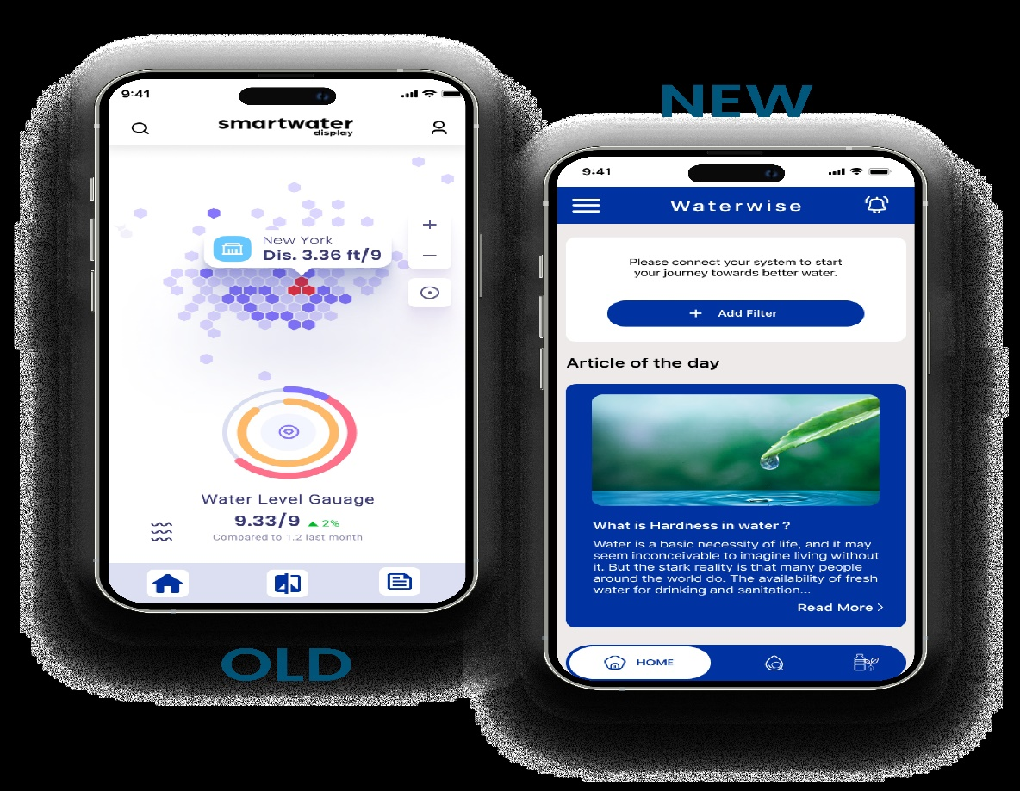

**3.3 Evaluation Method:**

User Testing:

* Conducted usability testing sessions with a diverse group of participants, including individuals of different ages, backgrounds, and technical proficiency levels.
* Task-based evaluations to assess the ease of use, navigation efficiency, and overall user satisfaction with the application.
* Gathered qualitative feedback through post-test interviews to identify user pain points, preferences, and suggestions for improvement.

Data Analysis:

* Collected quantitative data on user interactions, such as the frequency of app usage, time spent on different features, and completion rates for various tasks.
* Utilized analytics tools to track user engagement metrics, including the number of downloads, active users, and retention rates over time.
* Performed statistical analysis to identify correlations between user demographics, usage patterns, and satisfaction levels.

Environmental Impact Assessment:

* Evaluated the application's effectiveness in promoting water conservation behaviours and reducing environmental impact through surveys or interviews with users.
* Analysed data on water usage patterns before and after using the WaterWise application to measure changes in behaviour and resource consumption.

**3.4 Evaluation Results:**

User Testing:

* Participants expressed high satisfaction with the application's intuitive interface and ease of navigation.
* Users appreciated the real-time access to water quality data, which increased their awareness of local water conditions and potential risks.
* Feedback highlighted the effectiveness of the educational resources in fostering understanding of water conservation principles and motivating behaviour change.

Data Analysis:

* Quantitative analysis revealed a steady increase in app downloads and active users over time, indicating growing interest and engagement with the WaterWise application.
* User engagement metrics, such as time spent on the app and frequency of access, demonstrated sustained user interest and usage.

**Discussion:**

The evaluation results indicate that the WaterWise application has achieved significant success in empowering users with insights into water quality and promoting sustainable water management practices. However, there are opportunities for further enhancement, particularly in refining data visualization techniques, expanding the scope of water quality metrics, and incentivizing user participation through gamification elements. Overall, the evaluation results provide valuable feedback for guiding future iterations and enhancements of the WaterWise application, ensuring its continued effectiveness in empowering individuals to make informed decisions about water usage and conservation.

**Conclusion:**

The evaluation of the WaterWise application has provided valuable insights into its effectiveness in empowering users with knowledge and tools to actively engage in sustainable water management practices. Through a combination of user testing, data analysis, and expert review, the strengths and areas for improvement of the application have been identified.

Overall, the results indicate that the WaterWise application has achieved success in several key areas. Users appreciate its intuitive interface, real-time access to water quality data, and educational resources, which have increased their awareness of local water conditions and motivated them to adopt water conservation behaviours. The application has also demonstrated steady growth in user engagement, with a growing number of downloads and active users over time.

However, there are opportunities for further enhancement to maximize the impact of the WaterWise application. Suggestions for improvement include refining data visualization techniques, expanding the range of water quality metrics, and incorporating additional features to incentivize user participation. By addressing these areas, the WaterWise application can continue to evolve as a valuable tool for empowering individuals to make informed decisions about water usage and conservation.

**ACKNOWLEDGMENTS:**

We express our gratitude to all the reviewers who actively participated in the successive design workshops and contributed their practical insights and academic expertise to address this issues.

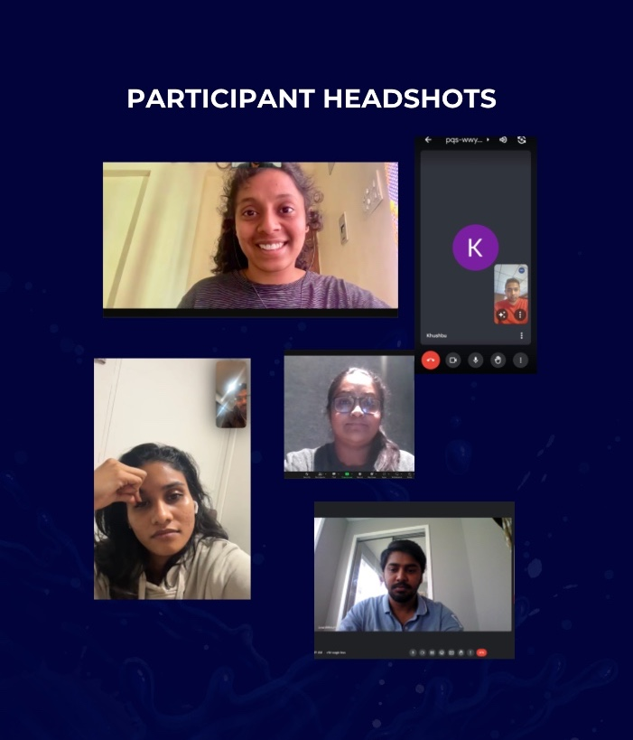

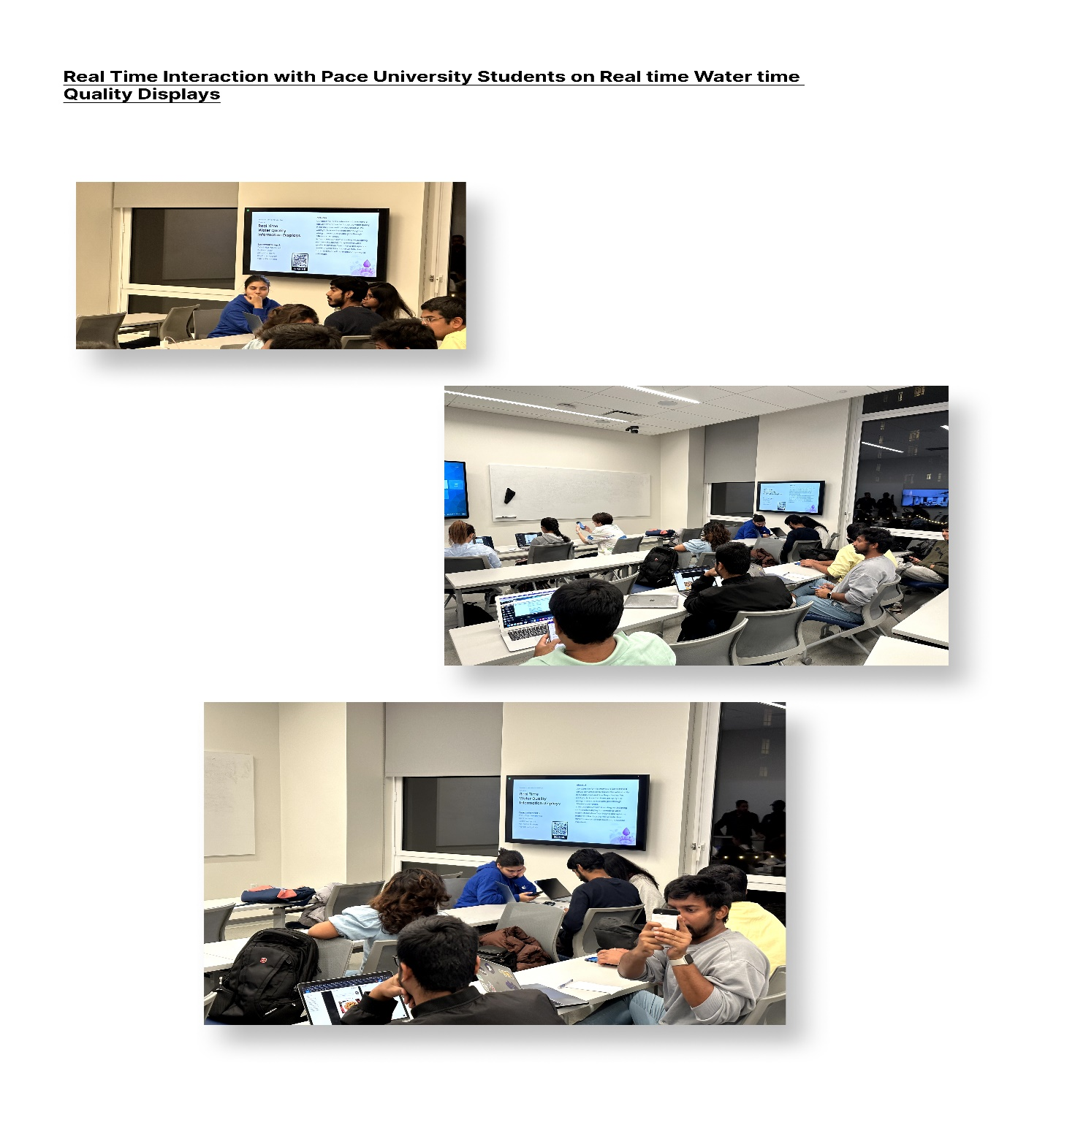

**Figma Prototype Link:**

https://www.figma.com/proto/WJ87r7DLtDrfJhJrabhrtO/ResearchMthds-for-User-Exp?type=design&node-id=1397- 4004&t=pV23uIk6rmYhCncL-0&scaling=scale-down&pageid=761%3A1499&starting-point-node-id=1397%3A4004

**References:**

<https://dashboard.waterdata.usgs.gov/app/nwd/en/?aoi=default>